

EasyBank India Ltd. is a fictitious commercial institution with several branches across the country. It provides financialservices, including issuing money in the form of coins, banknotes or debit cards, receiving deposits of money, lending money and processing transactions. The bank accepts deposits from customers and in turn makes loans based on those deposits.

Services typically offered by Easy Bank are:

* Taking deposits from the customers and issuing current and savings accounts to individuals and businesses
* Extending loans to individuals and businesses
* Cashing cheques
* Issuing credit cards, ATM cards, and debit cards
* Storing valuables, particularly in a safe deposit lockers
* Cashing and distributing bank rolls
* Consumer & commercial financial advisory services

As is the case with most organizations, Easy Bank India Ltd has a large amount of data about its customers, products, and employees. Much of this information is stored in transactional systems in various formats. The major issue the bank faced was reports needed by senior management for strategic business decisions were always delayed. The bank decided to implement Business Intelligence and a Data Warehouse which will solve the problem. The need was felt around the following:

* Summary information to assess performance v/s target and benchmark
* Discover low performing and high performing areas
* Discover causes of low / high performance
* Bringing data together for a single point of truth
* Make better decisions with timely reports and increased collaboration
* Real-time analysis of information on integrated systems
* Get instantaneous answers to those "what if" questions
* Deploy analytical techniques – correlation, pareto analysis, trend analysis, distribution analysis

Using applications and processes such as SAS Data Integration Studio, the transactional information of the bank was extracted, transformed, and loaded into a data warehouse.   
  
Data marts were created to meet the needs of specific functions such as ATMs, Loans, etc.

This case study is based on the loan data.The Analysis Tasks are listed by subject.

The Star Schema Design for the same is as shown below:

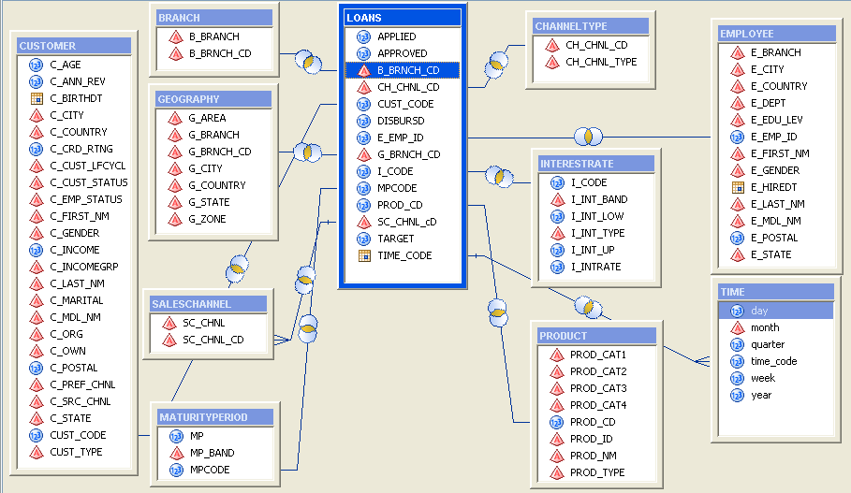

Base SAS

1. City-wise Pending disbursals – make a data set with a new column called Pending_Disburse_Amt
2. Employee Performance – Loans applied v/s approved
3. Top employees Who have the highest amount of rejected loans
4. Top five cities based on the disbursed loan amounts
5. Branch Performance - loans applied, approved, disbursed

* Branch-wise maximum amount disbursed
* Branch with the least number of loans applied and maximum loans applied
* Which loans are nearing maturity period
* Which branch has the least approved loans

1. Give Loans Applied based on Sales channels
2. AnalyzeLoan Performance. – (which type has the highest amount of loans applied)

* Fixed v/s Floating
* Home v/s Automobile-Car v/s Equipment - Machinery

1. Report the maximum Sales Channel used for loan applications
2. Give Loans disbursed based on Prod Cat 2 and 3. Create each as a separate dataset
3. Give amount of Loans based on Maturity Period Bands
4. Which Year has the highest loan applications, approved and disbursed.

Give each as a separate query?

1. Which Month has the highest loan applications for each year.Do you find

any pattern across the years?

1. Read the customers raw data file and create a dataset named Customer

having all records.

1. Create three datasets: Active_Customers, Inactive_Customers and

Dormant_Customers

1. Create a summary table which has city-wise active customer loan details.

Select the appropriate fields. (Accumulating Total)

1. Which city has the highest customers?
2. What is the Age group where maximum loans have been approved?
3. Give age-group wise loans disbursed.
4. Give total number of customers in each income group.
5. Applied loan amount based on marital status.
   1. If unmarried which age group has applied the most loans?
   2. If married which age groups have applied the most loans
6. How many individuals, NRI’s and Corporates have applied for loans. How

many have been disbursed and how many have been rejected.

1. Give loan details for customer demographics based on employment status:

Employed, Unemployed, Self Employed.

1. Read the customers raw datafile to read only records for Active customers

(use single trailing)

1. Create a format to create customer age band (based on customer age)

* Young (18 – 25 yrs)
* Middle age (25 – 45 yrs)
* Senior Citizens (45 yrs and above)

1. Use the Quarterwise_Loans_Applied data set shown in Fig 1. And transpose

the same as shown in Fig 2. Give two solutions:

* Using Do loops and Arrays
* Using PROC Transpose

Fig 1.

|  |  |  |
| --- | --- | --- |
| Year | Quarter | Total_Applied_Loans_Amount |
| 2003 | 2 | 296454235 |
| 2003 | 3 | 453937044 |
| 2003 | 4 | 452661314 |
| 2004 | 1 | 451731513 |
| 2004 | 2 | 445774435 |
| 2004 | 3 | 449804986 |
| 2004 | 4 | 449888460 |
| 2005 | 1 | 448866537 |
| 2005 | 2 | 301305214 |

Fig 2.

|  |  |  |  |  |
| --- | --- | --- | --- | --- |
| Year | Quarter1 | Quarter2 | Quarter3 | Quarter4 |
| 2003 | . | 296454235 | 453937044 | 452661314 |
| 2004 | 451731513 | 445774435 | 449804986 | 449888460 |
| 2005 | 448866537 | 301305214 | . | . |

Macros

1. Write a macro program to give branch-wise loans details. The type of amount to be displayed should be accepted as a parameter. (Applied, Approved, Disbursed)
2. Convert the above macro to accept the branch as a parameter to give a report for a specific branch.
3. Write a macro to give loans applied based on marital status as parameter. The report title should contain the marital status.
4. Write a macro to give loans applied based on gender as parameter. The report title should contain the gender.
5. Using a macro create three datasets for customers: Employed, Unemployed and SelfEmployed. Pass the employment status as parameter to create the respective dataset.
6. Write a macro program to give employee details for a particular city passed as parameter which should give no of loans applied through each employee. In the output report, the city name should appear in the title and the total number of loans applied in the city should be displayed as footnote.
7. Modify the above macro to validate the city name passed as a parameter.
8. Write a macro program which takes product code as a parameter and reports the product name with total of applied, approved and disbursed loan amounts for the given product code passed and which has the total of applied loan amounts greater than INR. 267000000. The title of the report should be “Report for premium product <product_name>” . If the total of applied loans amounts is less than the given amount, then report title should be “Report for non-premium product <product_name>”.